**Signature:** 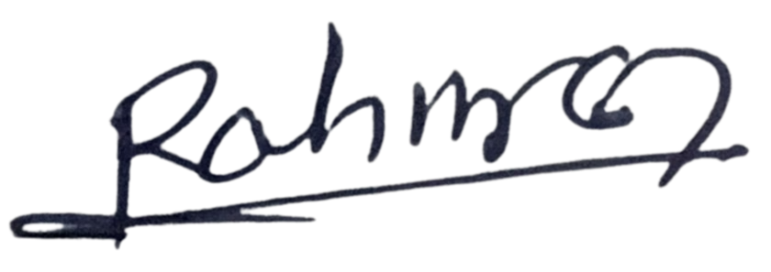

I, **RAHMAN MOHAMMAD MIZANUR**, voluntarily consented to work on a **Sunday or public holiday** for my **regular hourly or daily rate of pay.**

**Time sheet (July 2023)**

|  |  |  |  |  |  |
| --- | --- | --- | --- | --- | --- |
| **Section A** | | | | | |
| **Date** | **Time-In** | **Time-Out** | **Lunch OT (HR)** | **OT (HR)** | **Remarks** |
| 1 | 8 am | 7 pm | 0 | 2 | 26 & 28 Grove Drive |
| 2 |  |  |  |  |  |
| 3 | 8 am | 7 pm | 0 | 2 | 26 & 28 Grove Drive |
| 4 | 8 am | 7 pm | 0 | 2 | 26 & 28 Grove Drive |
| 5 | 8 am | 7 pm | 0 | 2 | 12 Holland Drive |
| 6 | 8 am | 7 pm | 0 | 2 | 12 Holland Drive |
| 7 | 8 am | 7 pm | 0 | 2 | 12 Holland Drive |
| 8 | 8 am | 7 pm | 0 | 2 | 12 Holland Drive |
| 9 |  |  |  |  |  |
| 10 | 8 am | 7 pm | 0 | 2 | 12 Holland Drive |
| 11 | 8 am | 7 pm | 0 | 2 | 12 Holland Drive |
| 12 | 8 am | 7 pm | 0 | 2 | 12 Holland Drive |
| 13 | 8 am | 7 pm | 0 | 2 | 12 Holland Drive |
| 14 | 8 am | 7 pm | 0 | 2 | 12 Holland Drive |
| 15 | 8 am | 7 pm | 0 | 2 | 12 Holland Drive |
| 16 |  |  |  |  |  |
| 17 | 8 am | 7 pm | 0 | 2 | 12 Holland Drive |
| 18 | 8 am | 7 pm | 0 | 2 | 12 Holland Drive |
| 19 | 8 am | 7 pm | 0 | 2 | 12 Holland Drive |
| 20 | 8 am | 7 pm | 0 | 2 | 12 Holland Drive |
| 21 | 8 am | 7 pm | 0 | 2 | 12 Holland Drive |
| 22 | 8 am | 7 pm | 0 | 2 | 12 Holland Drive |
| 23 |  |  |  |  |  |
| 24 | 8 am | 7 pm | 0 | 2 | 12 Holland Drive |
| 25 | 8 am | 7 pm | 0 | 2 | 12 Holland Drive |
| 26 | 8 am | 7 pm | 0 | 2 | 12 Holland Drive |
| 27 | 8 am | 7 pm | 0 | 2 | 12 Holland Drive |
| 28 | 8 am | 7 pm | 0 | 2 | 12 Holland Drive |
| 29 | 8 am | 7 pm | 0 | 2 | 12 Holland Drive |
| 30 |  |  |  |  |  |
| 31 | 8 am | 7 pm | 0 | 2 | 12 Holland Drive |

|  |  |  |  |  |  |
| --- | --- | --- | --- | --- | --- |
| **Section B** | | | | | |
| **FOR OFFICIAL USE ONLY** | | **FOR SUPERVISOR USE ONLY** | | **FOR MANAGER USE ONLY** | |
| **Total WD (Day)** |  | **Name** | RAHMAN MOHAMMAD MIZANUR | **Name** | CHUA KAH PENG |
| **Total OT (HR)** |  | **Signature** |  | **Signature** |  |
| **FINAL ($)** | $ |
| **Date** | 31/07/2023 | **Date** | 31/07/2023 |

**Signature:** 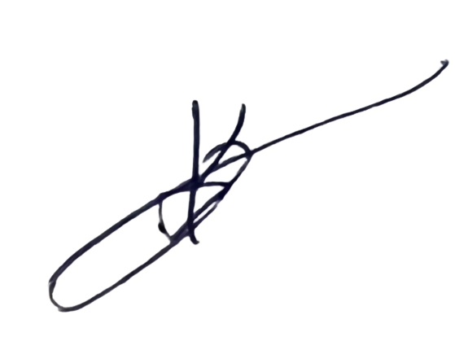

I, **SIKDER KABIR**, voluntarily consented to work on a **Sunday or public holiday** for my **regular hourly or daily rate of pay.**

**Time sheet (July 2023)**

|  |  |  |  |  |  |
| --- | --- | --- | --- | --- | --- |
| **Section A** | | | | | |
| **Date** | **Time-In** | **Time-Out** | **Lunch OT (HR)** | **OT (HR)** | **Remarks** |
| 1 | 8 am | 7 pm | 0 | 2 | 26 & 28 Grove Drive |
| 2 |  |  |  |  |  |
| 3 | 8 am | 7 pm | 0 | 2 | 26 & 28 Grove Drive |
| 4 | 8 am | 7 pm | 0 | 2 | 26 & 28 Grove Drive |
| 5 | 8 am | 7 pm | 0 | 2 | 26 & 28 Grove Drive |
| 6 | 8 am | 7 pm | 0 | 2 | 26 & 28 Grove Drive |
| 7 | 8 am | 7 pm | 0 | 2 | 26 & 28 Grove Drive |
| 8 | 8 am | 7 pm | 0 | 2 | 26 & 28 Grove Drive |
| 9 |  |  |  |  |  |
| 10 | 8 am | 7 pm | 0 | 2 | 26 & 28 Grove Drive |
| 11 | 8 am | 7 pm | 0 | 2 | 26 & 28 Grove Drive |
| 12 | 8 am | 7 pm | 0 | 2 | 26 & 28 Grove Drive |
| 13 | 8 am | 7 pm | 0 | 2 | 26 & 28 Grove Drive |
| 14 | 8 am | 7 pm | 0 | 2 | 26 & 28 Grove Drive |
| 15 | 8 am | 7 pm | 0 | 2 | 26 & 28 Grove Drive |
| 16 |  |  |  |  |  |
| 17 | 8 am | 7 pm | 0 | 2 | 26 & 28 Grove Drive |
| 18 | 8 am | 7 pm | 0 | 2 | 26 & 28 Grove Drive |
| 19 | 8 am | 7 pm | 0 | 2 | 26 & 28 Grove Drive |
| 20 | 8 am | 7 pm | 0 | 2 | 26 & 28 Grove Drive |
| 21 | 8 am | 7 pm | 0 | 2 | 26 & 28 Grove Drive |
| 22 | 8 am | 7 pm | 0 | 2 | 26 & 28 Grove Drive |
| 23 |  |  |  |  |  |
| 24 | 8 am | 7 pm | 0 | 2 | 26 & 28 Grove Drive |
| 25 | 8 am | 7 pm | 0 | 2 | 26 & 28 Grove Drive |
| 26 | 8 am | 7 pm | 0 | 2 | 26 & 28 Grove Drive |
| 27 | 8 am | 7 pm | 0 | 2 | 26 & 28 Grove Drive |
| 28 | 8 am | 7 pm | 0 | 2 | 26 & 28 Grove Drive |
| 29 | 8 am | 7 pm | 0 | 2 | 26 & 28 Grove Drive |
| 30 |  |  |  |  |  |
| 31 | 8 am | 7 pm | 0 | 2 | 26 & 28 Grove Drive |

|  |  |  |  |  |  |
| --- | --- | --- | --- | --- | --- |
| **Section B** | | | | | |
| **FOR OFFICIAL USE ONLY** | | **FOR SUPERVISOR USE ONLY** | | **FOR MANAGER USE ONLY** | |
| **Total WD (Day)** |  | **Name** | RAHMAN MOHAMMAD MIZANUR | **Name** | CHUA KAH PENG |
| **Total OT (HR)** |  | **Signature** |  | **Signature** |  |
| **FINAL ($)** | $ |
| **Date** | 31/07/2023 | **Date** | 31/07/2023 |

**Signature:** 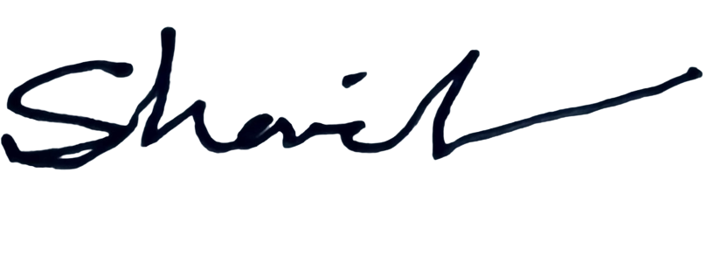

I, **ISLAM MD SHARIFUL**, voluntarily consented to work on a **Sunday or public holiday** for my **regular hourly or daily rate of pay.**

**Time sheet (July 2023)**

|  |  |  |  |  |  |
| --- | --- | --- | --- | --- | --- |
| **Section A** | | | | | |
| **Date** | **Time-In** | **Time-Out** | **Lunch OT (HR)** | **OT (HR)** | **Remarks** |
| 1 | 8 am | 7 pm | 0 | 2 | 26 & 28 Grove Drive |
| 2 |  |  |  |  |  |
| 3 | 8 am | 7 pm | 0 | 2 | 26 & 28 Grove Drive |
| 4 | 8 am | 7 pm | 0 | 2 | 26 & 28 Grove Drive |
| 5 | 8 am | 7 pm | 0 | 2 | 26 & 28 Grove Drive |
| 6 | 8 am | 7 pm | 0 | 2 | 26 & 28 Grove Drive |
| 7 | 8 am | 7 pm | 0 | 2 | 26 & 28 Grove Drive |
| 8 | 8 am | 7 pm | 0 | 2 | 26 & 28 Grove Drive |
| 9 |  |  |  |  |  |
| 10 | 8 am | 7 pm | 0 | 2 | 26 & 28 Grove Drive |
| 11 | 8 am | 7 pm | 0 | 2 | 26 & 28 Grove Drive |
| 12 | 8 am | 7 pm | 0 | 2 | 26 & 28 Grove Drive |
| 13 | 8 am | 7 pm | 0 | 2 | 26 & 28 Grove Drive |
| 14 | 8 am | 7 pm | 0 | 2 | 26 & 28 Grove Drive |
| 15 | 8 am | 7 pm | 0 | 2 | 26 & 28 Grove Drive |
| 16 |  |  |  |  |  |
| 17 | 8 am | 7 pm | 0 | 2 | 26 & 28 Grove Drive |
| 18 | 8 am | 7 pm | 0 | 2 | 26 & 28 Grove Drive |
| 19 | 8 am | 7 pm | 0 | 2 | 26 & 28 Grove Drive |
| 20 | 8 am | 7 pm | 0 | 2 | 26 & 28 Grove Drive |
| 21 | 8 am | 7 pm | 0 | 2 | 26 & 28 Grove Drive |
| 22 | 8 am | 7 pm | 0 | 2 | 26 & 28 Grove Drive |
| 23 |  |  |  |  |  |
| 24 | 8 am | 7 pm | 0 | 2 | 26 & 28 Grove Drive |
| 25 | 8 am | 7 pm | 0 | 2 | 26 & 28 Grove Drive |
| 26 | 8 am | 7 pm | 0 | 2 | 26 & 28 Grove Drive |
| 27 | 8 am | 7 pm | 0 | 2 | 26 & 28 Grove Drive |
| 28 | 8 am | 7 pm | 0 | 2 | 26 & 28 Grove Drive |
| 29 | 8 am | 7 pm | 0 | 2 | 26 & 28 Grove Drive |
| 30 |  |  |  |  |  |
| 31 | 8 am | 7 pm | 0 | 2 | 26 & 28 Grove Drive |

|  |  |  |  |  |  |
| --- | --- | --- | --- | --- | --- |
| **Section B** | | | | | |
| **FOR OFFICIAL USE ONLY** | | **FOR SUPERVISOR USE ONLY** | | **FOR MANAGER USE ONLY** | |
| **Total WD (Day)** |  | **Name** | RAHMAN MOHAMMAD MIZANUR | **Name** | CHUA KAH PENG |
| **Total OT (HR)** |  | **Signature** |  | **Signature** |  |
| **FINAL ($)** | $ |
| **Date** | 31/07/2023 | **Date** | 31/07/2023 |

**Signature:** 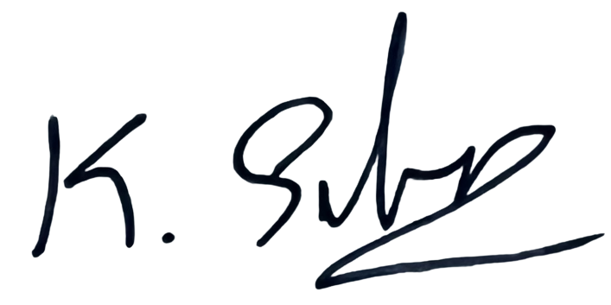

I, **KAMARAJ SILAMBARASAN**, voluntarily consented to work on a **Sunday or public holiday** for my **regular hourly or daily rate of pay.**

**Time sheet (July 2023)**

|  |  |  |  |  |  |
| --- | --- | --- | --- | --- | --- |
| **Section A** | | | | | |
| **Date** | **Time-In** | **Time-Out** | **Lunch OT (HR)** | **OT (HR)** | **Remarks** |
| 1 | 8 am | 7 pm | 0 | 2 | 26 & 28 Grove Drive |
| 2 |  |  |  |  |  |
| 3 | 8 am | 7 pm | 0 | 2 | 26 & 28 Grove Drive |
| 4 | 8 am | 7 pm | 0 | 2 | 26 & 28 Grove Drive |
| 5 | 8 am | 7 pm | 0 | 2 | 26 & 28 Grove Drive |
| 6 | 8 am | 7 pm | 0 | 2 | 26 & 28 Grove Drive |
| 7 | 8 am | 7 pm | 0 | 2 | 26 & 28 Grove Drive |
| 8 | 8 am | 7 pm | 0 | 2 | 26 & 28 Grove Drive |
| 9 |  |  |  |  |  |
| 10 | 8 am | 7 pm | 0 | 2 | 26 & 28 Grove Drive |
| 11 | 8 am | 7 pm | 0 | 2 | 26 & 28 Grove Drive |
| 12 | 8 am | 7 pm | 0 | 2 | 26 & 28 Grove Drive |
| 13 | 8 am | 7 pm | 0 | 2 | 26 & 28 Grove Drive |
| 14 | 8 am | 7 pm | 0 | 2 | 26 & 28 Grove Drive |
| 15 | 8 am | 7 pm | 0 | 2 | 26 & 28 Grove Drive |
| 16 |  |  |  |  |  |
| 17 | 8 am | 7 pm | 0 | 2 | 26 & 28 Grove Drive |
| 18 | 8 am | 7 pm | 0 | 2 | 26 & 28 Grove Drive |
| 19 | 8 am | 7 pm | 0 | 2 | 26 & 28 Grove Drive |
| 20 | 8 am | 7 pm | 0 | 2 | 26 & 28 Grove Drive |
| 21 | 8 am | 7 pm | 0 | 2 | 26 & 28 Grove Drive |
| 22 | 8 am | 7 pm | 0 | 2 | 26 & 28 Grove Drive |
| 23 |  |  |  |  |  |
| 24 | 8 am | 7 pm | 0 | 2 | 26 & 28 Grove Drive |
| 25 | 8 am | 7 pm | 0 | 2 | 26 & 28 Grove Drive |
| 26 | 8 am | 7 pm | 0 | 2 | 26 & 28 Grove Drive |
| 27 | 8 am | 7 pm | 0 | 2 | 26 & 28 Grove Drive |
| 28 | 8 am | 7 pm | 0 | 2 | 26 & 28 Grove Drive |
| 29 | 8 am | 7 pm | 0 | 2 | 26 & 28 Grove Drive |
| 30 |  |  |  |  |  |
| 31 | 8 am | 7 pm | 0 | 2 | 26 & 28 Grove Drive |

|  |  |  |  |  |  |
| --- | --- | --- | --- | --- | --- |
| **Section B** | | | | | |
| **FOR OFFICIAL USE ONLY** | | **FOR SUPERVISOR USE ONLY** | | **FOR MANAGER USE ONLY** | |
| **Total WD (Day)** |  | **Name** | RAHMAN MOHAMMAD MIZANUR | **Name** | CHUA KAH PENG |
| **Total OT (HR)** |  | **Signature** |  | **Signature** |  |
| **FINAL ($)** | $ |
| **Date** | 31/07/2023 | **Date** | 31/07/2023 |

**Signature:** 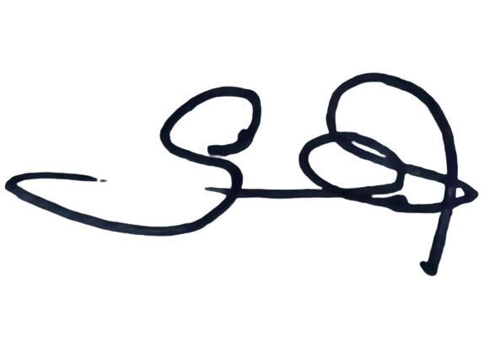

I, **SUBRAMANI SARAVANAN**, voluntarily consented to work on a **Sunday or public holiday** for my **regular hourly or daily rate of pay.**

**Time sheet (July 2023)**

|  |  |  |  |  |  |
| --- | --- | --- | --- | --- | --- |
| **Section A** | | | | | |
| **Date** | **Time-In** | **Time-Out** | **Lunch OT (HR)** | **OT (HR)** | **Remarks** |
| 1 | 8 am | 7 pm | 0 | 2 | 26 & 28 Grove Drive |
| 2 |  |  |  |  |  |
| 3 | 8 am | 7 pm | 0 | 2 | 26 & 28 Grove Drive |
| 4 | 8 am | 7 pm | 0 | 2 | 26 & 28 Grove Drive |
| 5 | 8 am | 7 pm | 0 | 2 | 26 & 28 Grove Drive |
| 6 | 8 am | 7 pm | 0 | 2 | 26 & 28 Grove Drive |
| 7 | 8 am | 7 pm | 0 | 2 | 26 & 28 Grove Drive |
| 8 | 8 am | 7 pm | 0 | 2 | 26 & 28 Grove Drive |
| 9 |  |  |  |  |  |
| 10 | 8 am | 7 pm | 0 | 2 | 26 & 28 Grove Drive |
| 11 | 8 am | 7 pm | 0 | 2 | 26 & 28 Grove Drive |
| 12 | 8 am | 7 pm | 0 | 2 | 26 & 28 Grove Drive |
| 13 | 8 am | 7 pm | 0 | 2 | 26 & 28 Grove Drive |
| 14 | 8 am | 7 pm | 0 | 2 | 26 & 28 Grove Drive |
| 15 | 8 am | 7 pm | 0 | 2 | 26 & 28 Grove Drive |
| 16 |  |  |  |  |  |
| 17 | 8 am | 7 pm | 0 | 2 | 12 Holland Drive |
| 18 | 8 am | 7 pm | 0 | 2 | 12 Holland Drive |
| 19 | 8 am | 7 pm | 0 | 2 | 12 Holland Drive |
| 20 | 8 am | 7 pm | 0 | 2 | 12 Holland Drive |
| 21 | 8 am | 7 pm | 0 | 2 | 12 Holland Drive |
| 22 | 8 am | 7 pm | 0 | 2 | 12 Holland Drive |
| 23 |  |  |  |  |  |
| 24 | 8 am | 7 pm | 0 | 2 | 12 Holland Drive |
| 25 | 8 am | 7 pm | 0 | 2 | 12 Holland Drive |
| 26 | 8 am | 7 pm | 0 | 2 | 12 Holland Drive |
| 27 | 8 am | 7 pm | 0 | 2 | 12 Holland Drive |
| 28 | 8 am | 7 pm | 0 | 2 | 12 Holland Drive |
| 29 | 8 am | 7 pm | 0 | 2 | 12 Holland Drive |
| 30 |  |  |  |  |  |
| 31 | 8 am | 7 pm | 0 | 2 | 12 Holland Drive |

|  |  |  |  |  |  |
| --- | --- | --- | --- | --- | --- |
| **Section B** | | | | | |
| **FOR OFFICIAL USE ONLY** | | **FOR SUPERVISOR USE ONLY** | | **FOR MANAGER USE ONLY** | |
| **Total WD (Day)** |  | **Name** | RAHMAN MOHAMMAD MIZANUR | **Name** | CHUA KAH PENG |
| **Total OT (HR)** |  | **Signature** |  | **Signature** |  |
| **FINAL ($)** | $ |
| **Date** | 31/07/2023 | **Date** | 31/07/2023 |

**Signature:** 

I, **BOYRAGI SHOYON**, voluntarily consented to work on a **Sunday or public holiday** for my **regular hourly or daily rate of pay.**

**Time sheet (July 2023)**

|  |  |  |  |  |  |
| --- | --- | --- | --- | --- | --- |
| **Section A** | | | | | |
| **Date** | **Time-In** | **Time-Out** | **Lunch OT (HR)** | **OT (HR)** | **Remarks** |
| 1 | 8 am | 7 pm | 0 | 2 | 26 & 28 Grove Drive |
| 2 |  |  |  |  |  |
| 3 | 8 am | 7 pm | 0 | 2 | 26 & 28 Grove Drive |
| 4 | 8 am | 7 pm | 0 | 2 | 26 & 28 Grove Drive |
| 5 | 8 am | 7 pm | 0 | 2 | 26 & 28 Grove Drive |
| 6 | 8 am | 7 pm | 0 | 2 | 26 & 28 Grove Drive |
| 7 | 8 am | 7 pm | 0 | 2 | 26 & 28 Grove Drive |
| 8 | 8 am | 7 pm | 0 | 2 | 26 & 28 Grove Drive |
| 9 |  |  |  |  |  |
| 10 | 8 am | 7 pm | 0 | 2 | 26 & 28 Grove Drive |
| 11 | 8 am | 7 pm | 0 | 2 | 26 & 28 Grove Drive |
| 12 | 8 am | 7 pm | 0 | 2 | 26 & 28 Grove Drive |
| 13 | 8 am | 7 pm | 0 | 2 | 26 & 28 Grove Drive |
| 14 | 8 am | 7 pm | 0 | 2 | 26 & 28 Grove Drive |
| 15 | 8 am | 7 pm | 0 | 2 | 26 & 28 Grove Drive |
| 16 |  |  |  |  |  |
| 17 | 8 am | 7 pm | 0 | 2 | 26 & 28 Grove Drive |
| 18 | 8 am | 7 pm | 0 | 2 | 26 & 28 Grove Drive |
| 19 | 8 am | 7 pm | 0 | 2 | 26 & 28 Grove Drive |
| 20 | 8 am | 7 pm | 0 | 2 | 26 & 28 Grove Drive |
| 21 | 8 am | 7 pm | 0 | 2 | 26 & 28 Grove Drive |
| 22 | 8 am | 7 pm | 0 | 2 | 26 & 28 Grove Drive |
| 23 |  |  |  |  |  |
| 24 | 8 am | 7 pm | 0 | 2 | 26 & 28 Grove Drive |
| 25 | 8 am | 7 pm | 0 | 2 | 26 & 28 Grove Drive |
| 26 | 8 am | 7 pm | 0 | 2 | 26 & 28 Grove Drive |
| 27 | 8 am | 7 pm | 0 | 2 | 26 & 28 Grove Drive |
| 28 | 8 am | 7 pm | 0 | 2 | 26 & 28 Grove Drive |
| 29 | 8 am | 7 pm | 0 | 2 | 26 & 28 Grove Drive |
| 30 |  |  |  |  |  |
| 31 | 8 am | 7 pm | 0 | 2 | 26 & 28 Grove Drive |

|  |  |  |  |  |  |
| --- | --- | --- | --- | --- | --- |
| **Section B** | | | | | |
| **FOR OFFICIAL USE ONLY** | | **FOR SUPERVISOR USE ONLY** | | **FOR MANAGER USE ONLY** | |
| **Total WD (Day)** |  | **Name** | RAHMAN MOHAMMAD MIZANUR | **Name** | CHUA KAH PENG |
| **Total OT (HR)** |  | **Signature** |  | **Signature** |  |
| **FINAL ($)** | $ |
| **Date** | 31/07/2023 | **Date** | 31/07/2023 |

I, **RAMALINGAM KULANTHAIVEL**, voluntarily consented to work on a **Sunday or public holiday** for my **regular hourly or daily rate of pay.**

**Time sheet (July 2023)**

|  |  |  |  |  |  |
| --- | --- | --- | --- | --- | --- |
| **Section A** | | | | | |
| **Date** | **Time-In** | **Time-Out** | **Lunch OT (HR)** | **OT (HR)** | **Remarks** |
| 1 | - | - | - | - | - |
| 2 |  |  |  |  |  |
| 3 | - | - | - | - | - |
| 4 | - | - | - | - | - |
| 5 | - | - | - | - | - |
| 6 | - | - | - | - | - |
| 7 | - | - | - | - | - |
| 8 | - | - | - | - | - |
| 9 |  |  |  |  |  |
| 10 | 8 am | 7 pm | 0 | 2 | 12 Holland Drive |
| 11 | 8 am | 7 pm | 0 | 2 | 12 Holland Drive |
| 12 | 8 am | 7 pm | 0 | 2 | 12 Holland Drive |
| 13 | 8 am | 7 pm | 0 | 2 | 12 Holland Drive |
| 14 | 8 am | 7 pm | 0 | 2 | 12 Holland Drive |
| 15 | 8 am | 7 pm | 0 | 2 | 12 Holland Drive |
| 16 |  |  |  |  |  |
| 17 | 8 am | 7 pm | 0 | 2 | 12 Holland Drive |
| 18 | 8 am | 7 pm | 0 | 2 | 12 Holland Drive |
| 19 | 8 am | 7 pm | 0 | 2 | 12 Holland Drive |
| 20 | 8 am | 7 pm | 0 | 2 | 12 Holland Drive |
| 21 | 8 am | 7 pm | 0 | 2 | 12 Holland Drive |
| 22 | 8 am | 7 pm | 0 | 2 | 12 Holland Drive |
| 23 |  |  |  |  |  |
| 24 | 8 am | 7 pm | 0 | 2 | 12 Holland Drive |
| 25 | 8 am | 7 pm | 0 | 2 | 12 Holland Drive |
| 26 | 8 am | 7 pm | 0 | 2 | 12 Holland Drive |
| 27 | 8 am | 7 pm | 0 | 2 | 12 Holland Drive |
| 28 | 8 am | 7 pm | 0 | 2 | 12 Holland Drive |
| 29 | 8 am | 7 pm | 0 | 2 | 12 Holland Drive |
| 30 |  |  |  |  |  |
| 31 | 8 am | 7 pm | 0 | 2 | 12 Holland Drive |

|  |  |  |  |  |  |
| --- | --- | --- | --- | --- | --- |
| **Section B** | | | | | |
| **FOR OFFICIAL USE ONLY** | | **FOR SUPERVISOR USE ONLY** | | **FOR MANAGER USE ONLY** | |
| **Total WD (Day)** |  | **Name** | RAHMAN MOHAMMAD MIZANUR | **Name** | CHUA KAH PENG |
| **Total OT (HR)** |  | **Signature** |  | **Signature** |  |
| **FINAL ($)** | $ |
| **Date** | 31/07/2023 | **Date** | 31/07/2023 |

I, **LAI SEONG FOOK**, voluntarily consented to work on a **Sunday or public holiday** for my **regular hourly or daily rate of pay.**

**Time sheet (July 2023)**

|  |  |  |  |  |  |
| --- | --- | --- | --- | --- | --- |
| **Section A** | | | | | |
| **Date** | **Time-In** | **Time-Out** | **Lunch OT (HR)** | **OT (HR)** | **Remarks** |
| 1 | - | - | - | - | - |
| 2 |  |  |  |  |  |
| 3 | 8 am | 5 pm | 0 | 0 | 26 & 28 Grove Drive |
| 4 | 8 am | 5 pm | 0 | 0 | 26 & 28 Grove Drive |
| 5 | 8 am | 5 pm | 0 | 0 | 26 & 28 Grove Drive |
| 6 | 8 am | 5 pm | 0 | 0 | 26 & 28 Grove Drive |
| 7 | 8 am | 5 pm | 0 | 0 | 26 & 28 Grove Drive |
| 8 | 8 am | 5 pm | 0 | 0 | 26 & 28 Grove Drive |
| 9 |  |  |  |  |  |
| 10 | 8 am | 5 pm | 0 | 0 | 26 & 28 Grove Drive |
| 11 | 8 am | 5 pm | 0 | 0 | 26 & 28 Grove Drive |
| 12 | 8 am | 5 pm | 0 | 0 | 26 & 28 Grove Drive |
| 13 | 8 am | 5 pm | 0 | 0 | 26 & 28 Grove Drive |
| 14 | 8 am | 5 pm | 0 | 0 | 26 & 28 Grove Drive |
| 15 | 8 am | 5 pm | 0 | 0 | 26 & 28 Grove Drive |
| 16 |  |  |  |  |  |
| 17 | 8 am | 5 pm | 0 | 0 | 26 & 28 Grove Drive |
| 18 | 8 am | 6 pm | 0 | 1 | 26 & 28 Grove Drive |
| 19 | 8 am | 5 pm | 0 | 0 | 26 & 28 Grove Drive |
| 20 | 8 am | 5 pm | 0 | 0 | 26 & 28 Grove Drive |
| 21 | 8 am | 5 pm | 0 | 0 | 26 & 28 Grove Drive |
| 22 | 8 am | 5 pm | 0 | 0 | 26 & 28 Grove Drive |
| 23 |  |  |  |  |  |
| 24 | 8 am | 6 pm | 0 | 1 | 26 & 28 Grove Drive |
| 25 | 8 am | 5 pm | 0 | 0 | 26 & 28 Grove Drive |
| 26 | 8 am | 5 pm | 0 | 0 | 26 & 28 Grove Drive |
| 27 | 8 am | 5 pm | 0 | 0 | 26 & 28 Grove Drive |
| 28 | 8 am | 5 pm | 0 | 0 | 26 & 28 Grove Drive |
| 29 | 8 am | 5 pm | 0 | 0 | 26 & 28 Grove Drive |
| 30 |  |  |  |  |  |
| 31 | - | - | - | - | - |

|  |  |  |  |  |  |
| --- | --- | --- | --- | --- | --- |
| **Section B** | | | | | |
| **FOR OFFICIAL USE ONLY** | | **FOR SUPERVISOR USE ONLY** | | **FOR MANAGER USE ONLY** | |
| **Total WD (Day)** |  | **Name** | RAHMAN MOHAMMAD MIZANUR | **Name** | CHUA KAH PENG |
| **Total OT (HR)** |  | **Signature** |  | **Signature** |  |
| **FINAL ($)** | $ |
| **Date** | 31/07/2023 | **Date** | 31/07/2023 |